Sum Of Cubes Program

Number | 1 | 2 | 3 | 4 | 5 | 6 | 7 | 8
Cube | 1 | 8 | 27 | 64 | 125 | 216 | 343 | 512
Sum | 1 | 9 | 36 | 100 | 225 | 441 | 784 | 1296

The cube of a number n is equal to n*n*n.
You have been asked to write a program that will tell you the total of the cubes of the numbers from 1 to a number entered by the user.
Here is a Scratch program that describes the algorithm for doing this. Your task is to write this program in Visual Basic.
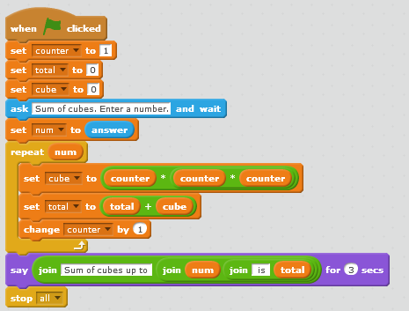
Variables have to be declared in Visual Basic. You can use the names you see here but must declare them properly in VB. They should be integers.
You don’t do output and input by ‘asking’ in VB. Check the reference for an example.

Instead of using the word repeat, you will need to use a FOR loop. Your FOR loop will count from 1 to the number the user enters (num). Look carefully at where the repeat block ends. Using a FOR loop, you will not need to change the value of counter – VB will do this for you.

