Resizing The Console

Click on the icon in the top left hand corner of the console window. Choose Properties.

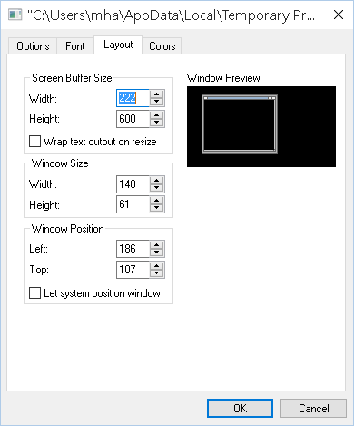
Change the width measurements in both boxes – around 140 should be OK for both settings. Click ok, close and rerun your program. If you can see all of the headings, you’re ok.

