Multiplication Tables Grid
 | 1 | 2 | 3 | 4 | 5 | 6 | 7 | 8 | 9 | 10 | 11 | 12 | 13 | 14 | 15
1 | 1 | 2 | 3 | 4 | 5 | 6 | 7 | 8 | 9 | 10 | 11 | 12 | 13 | 14 | 15
2 | 2 | 4 | 6 | 8 | 10 | 12 | 14 | 16 | 18 | 20 | 22 | 24 | 26 | 28 | 30
3 | 3 | 6 | 9 | 12 | 15 | 18 | 21 | 24 | 27 | 30 | 33 | 36 | 39 | 42 | 45
4 | 4 | 8 | 12 | 16 | 20 | 24 | 28 | 32 | 36 | 40 | 44 | 48 | 52 | 56 | 60
5 | 5 | 10 | 15 | 20 | 25 | 30 | 35 | 40 | 45 | 50 | 55 | 60 | 65 | 70 | 75
6 | 6 | 12 | 18 | 24 | 30 | 36 | 42 | 48 | 54 | 60 | 66 | 72 | 78 | 84 | 90
7 | 7 | 14 | 21 | 28 | 35 | 42 | 49 | 56 | 63 | 70 | 77 | 84 | 91 | 98 | 105
8 | 8 | 16 | 24 | 32 | 40 | 48 | 56 | 64 | 72 | 80 | 88 | 96 | 104 | 112 | 120
9 | 9 | 18 | 27 | 36 | 45 | 54 | 63 | 72 | 81 | 90 | 99 | 108 | 117 | 126 | 135
10 | 10 | 20 | 30 | 40 | 50 | 60 | 70 | 80 | 90 | 100 | 110 | 120 | 130 | 140 | 150
11 | 11 | 22 | 33 | 44 | 55 | 66 | 77 | 88 | 99 | 110 | 121 | 132 | 143 | 154 | 165
12 | 12 | 24 | 36 | 48 | 60 | 72 | 84 | 96 | 108 | 120 | 132 | 144 | 156 | 168 | 180
13 | 13 | 26 | 39 | 52 | 65 | 78 | 91 | 104 | 117 | 130 | 143 | 156 | 169 | 182 | 195
14 | 14 | 28 | 42 | 56 | 70 | 84 | 98 | 112 | 126 | 140 | 154 | 168 | 182 | 196 | 210
15 | 15 | 30 | 45 | 60 | 75 | 90 | 105 | 120 | 135 | 150 | 165 | 180 | 195 | 210 | 225

Can you explain how a person might use this grid to multiply together two numbers from 1 – 15?
Visual Basic Program
Your program will have the line Console.Readline() as its last line. The last line comes before the words End Sub.
Step 1 – Heading Row
Here is the actual code for the first step. Study it carefully.
For x As Integer = 1 To 15
Console.Write("{0}{1}", vbTab, x)
Next
Console.WriteLine()
The For & Next lines determine that there will be 15 repetitions. The second output line is the one to look at. It outputs a tab character and the number of the repetition.
The Console.Writeline() statement is like getting the computer to press the ‘ENTER’ key.
Copy and run this code. You will not be able to see the headings properly when you do. Find the document called Resizing The Console and follow the instructions until you can see things properly.
Step 2 – Rows
Look again at the table. We’ve done one row. You need another 15 rows. Earlier, we called the loop variable x because it was telling us the column of the number.
You can think of the row number as y.
- Create a For and Next loop, using y instead of x. Output the value of y using a Console.Write statement like the one for the heading. You only need to write y in the brackets – Console.Write(y).
- Add another line straight after that does a line break for you.
Run the program with your new code – you should have (screenshot cut down – goes up to 15),
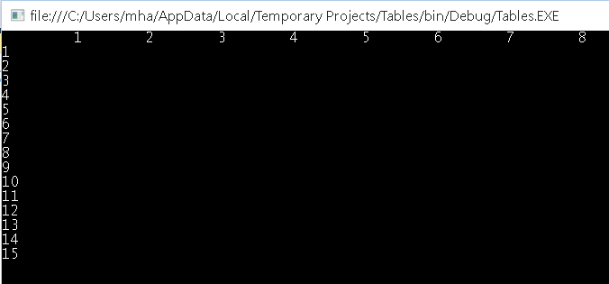
Step 3 – The Rest Of The Row
You should have written exactly 4 lines of code for Step 2. One of those statements made a line break. You need to write the rest of the code immediately before this line. Make space for that now.
Look at how the heading was created. You need to copy that code, with only one tiny change. Instead of outputting the value of x, it should output x*y. This creates the row of products. Add this code, make the change and test the program. Your loop with x is inside the loop that outputs the rows. That makes it repeat once for each row.
Step 4– Death Or Glory
There has to be more action to be had here. The quick way to edit your code to make it useful is to replace the term vbTab with “,”, in the quotes, like that. Change the 15s to something a little more ambitious. Go for something like 24. Run the program. Remember how you resized the console window, look on that menu now for an option to edit. Choose the option to mark and then you’ll be able to highlight stuff in the console. Press enter to copy highlighted text.
Slap open a new Word document. Page Layout ribbon – orientation = landscape, margins = narrow. Type title using title case. Press enter. Paste text you copied. Highlight text. Insert ribbon, Table, convert text to table. Choose commas as the separator. If you selected only the copied text, you should now have a lovely table. Format and, somewhere at the bottom of the page, add Your Name & Visual Basic. Format, save.

